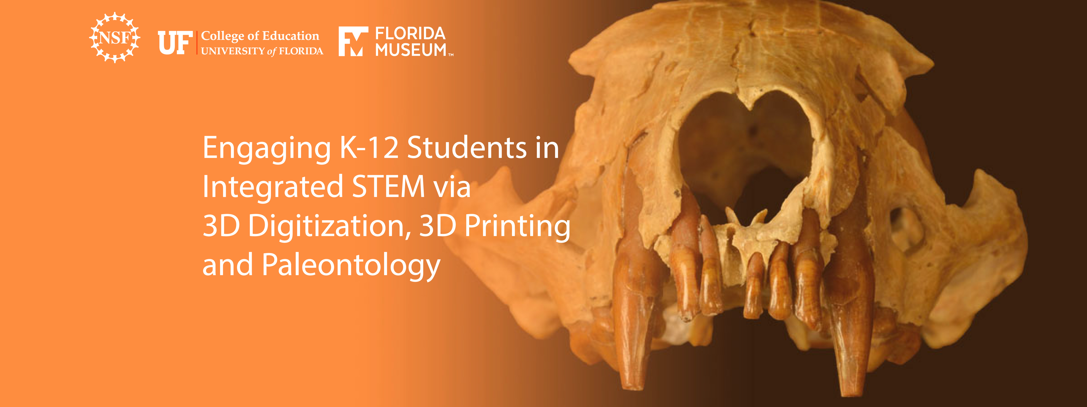

AUTHOR (S)
Name of the teacher/scientist and associated schools

LESSON TITLE
e.g., How Big Was Megalodon?

GRADE LEVEL
e.g., 6th – 7th grade

TIME FRAME
e.g., two 45-minute class periods
DRIVING QUESTION
e.g., How big was megalodon?
A good question is feasible, worthwhile, contextualized, meaningful, and ethical (Krajcik & Czerniak, 2013). The driving question captures the heart of the project by providing purpose using clear and compelling language. Driving questions (also called compelling questions) pose simply stated real world dilemmas. They pose predicaments that students find interesting and actually want to answer. What is a compelling question for a teacher may not be a compelling question for a student!

LEARNING GOALS
Think of learning goals as the consequence or product of the 3 dimensions associated with the performance expectation(s) of your lesson.

Please don’t put NGSS expectations here. There is a table below for that.

To identify the 3 dimensions on your performance expectation, we recommend you use the NSTA platform:
http://ngss.nsta.org/AccessStandardsByDCI.aspx

COLLABORATIONS
Describe the types of collaborative work that will occur during the project. Simple placement of students in groups does not ensure effective collaboration. How will you facilitate effective collaboration within and across teams and possibly even classrooms?
STEM INTEGRATION
Describe the science, math, engineering, and technology knowledge and skills this activity helps develop.

ASSESSMENT
What artifacts will students develop during the project and how will these projects be assessed. To be effective, artifacts need to address the driving question and demonstrate student understanding of the learning goals by reflecting the learning performances you identified above. If you plan to use a rubric, please paste it here.
Buck Institute’s PBL Rubrics: http://bie.org/objects/cat/rubrics
How will your assessment incorporate student understanding of the 3 dimensions of learning - disciplinary core ideas, crosscutting concepts, and scientific/engineering practices?
a) Formative assessments:
b) Summative assessment(s):

ANCHORING EVENT & PROCEDURE
Describe how you plan to trigger students’ interest in the question and problem (e.g. invite a scientist to situate the problem, show a PBS video clip explaining its causes and effects etc.).

Explain the specific sequence of activities that will scaffold student learning. A good frameworks for developing procedures is the 5E model (http://bscs.org/bscs-5e-instructional-model). Does the procedure meet the following criteria: http://bie.org/object/document/pbl_essential_elements_checklist

DAY 1:
If you have 5 E’s (Engage, Explore, Explain, Extend, Elaborate, and Evaluate), please insert them withing the days as they appear.
Lorem ipsum dolor sit amet, consectetur adipiscing elit. Integer nec odio. Praesent libero. Sed cursus ante dapibus diam. Sed nisi. Nulla quis sem at nibh elementum imperdiet. Duis sagittis ipsum. Praesent mauris. Fusce nec tellus sed augue semper porta. Mauris massa.
DAY 2
Lorem ipsum dolor sit amet, consectetur adipiscing elit. Integer nec odio. Praesent libero. Sed cursus ante dapibus diam. Sed nisi. Nulla quis sem at nibh elementum imperdiet. Duis sagittis ipsum. Praesent mauris. Fusce nec tellus sed augue semper porta. Mauris massa.
DAY 3
Lorem ipsum dolor sit amet, consectetur adipiscing elit. Integer nec odio. Praesent libero. Sed cursus ante dapibus diam. Sed nisi. Nulla quis sem at nibh elementum imperdiet. Duis sagittis ipsum. Praesent mauris. Fusce nec tellus sed augue semper porta. Mauris massa.

STANDARDS
NEXT GENERATION SCIENCE STANDARDS (NGSS)
List relevant NGSS standards for the intended grade level.
http://www.nextgenscience.org/search-standards

Insert your performance expectation here:
Analyze and interpret data from fossils to provide evidence of the organisms and the environments in which they lived long ago. 3-LS4-1

Science Practices | Connection to the Lesson
Find it here:
http://ngss.nsta.org/AccessStandardsByDCI.aspx

Disciplinary Core Ideas | Connection to the Lesson
Find it here:
http://ngss.nsta.org/AccessStandardsByDCI.aspx

Crosscutting Concepts | Connection to the Lesson
Find it here:
http://ngss.nsta.org/AccessStandardsByDCI.aspx

CCSS STANDARDS
List relevant CCSS state standards for the intended grade level for math and/or language arts.
http://www.corestandards.org/Math/
http://www.corestandards.org/ELA-Literacy/

OTHER STANDARDS
(optional – examples are ISTE standards, 21st century skills and 4C’s etc.)
http://www.iste.org/standards/iste-standards
http://www.p21.org/storage/documents/docs/P21_Framework_Definitions_New_Logo_2015.pdf
http://www.p21.org/component/content/section/9

RESOURCES & MATERIALS
List the resources and materials that teachers may find useful when they implement this project-based lesson. Common examples are YouTube videos, TED Talks, simulation tools, research briefs etc.

KEY ACADEMIC AND/OR SCIENTIFIC LANGUAGE
List the terms used in the lesson and definitions (e.g., deep time, brachiopod etc.).
Some of the many paleontology glossaries:
http://palaeos.com/paleontology/glossary.html
http://www.fossilmall.com/Science/Glossary.htm

PRIOR KNOWLEDGE
Explain what knowledge and skills students should have developed before engaging in this project-based lesson.

