Megalodon is a teensy bit scary, and my name is:
Notes Outline to Accompany Megalodon Powerpoint

Megalodon: The _______________________________________________________________________________________
Shark teeth can: ________________________________________________________________________________________

Sometimes __________________________________________________________________________

Indicate ______________________________________________________________________________

Scientists still debate __________________________ (or ________________________________________)
Megalodon’s size

-Different ____________________________________________________________________________

- All __________________________________________________________________________________

- Most ________________________________________________________________________________

The Circle of Life!
A shark’s skeleton is composed of ___________________________, which does not

____________________________________________________.

- However, ____________________________________________________________________________

Growth rings are preserved in shark vertebrae

- Shark ______________________________________________________________________________________

-Growth rings ______________________________________________________________________________

- Number of rings indicates _______________________________________________________________

What did Megalodon Eat?
Megalodon was the ________________________________________________________________________

- It would ____________________________________________________________________________________

An adult female probably weighed over __________________________________________

- Megalodon most likely ate _____________, ________________________, ________________,

_______________________, and whatever else it wanted!

Estimates show Megalodon would ________________________________________________

When Was Megalodon alive?
Megalodon lived from ______________________________________________________________________
-Fossil teeth and ____________________________________________________________________

-Megalodon is ___________________________!!

Meg evolved to eat giant whales that appeared as the oceans cooled in

the ___________________________________________________________________________
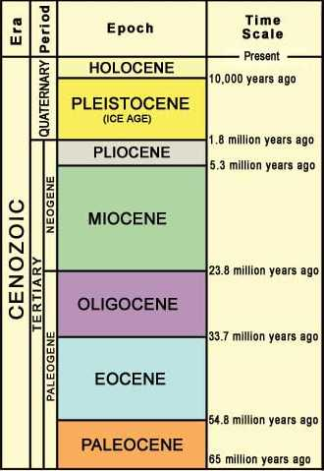
Where did Megalodon Live?

Megalodon had a ___________________________________________________________

- _______________________________________________________________________________

- _____________________________________________________________________(Pelagic)

- Most likely had _______________________________________________________________

Where do we find teeth today?

- ______________________________________________________
- Florida, North and South Carolina, California

- ______________________________________________________
- Peru, Chile, Venezuela, Costa Rica, Panama

- ______________________________________________________
- Morocco

- ______________________________________________________
- Belgium

Collecting Megalodon

- Shark teeth, including Megalodon, are ___________________________________________

_______________________________________________________________________________________

-They are abundant because _______________________________________________________

________________________________________________________________________________________

- Megalodon teeth are coveted for their __________________________________________

Who is Megalodon related to?

- Megalodon is a ____________________________________ related to modern

_____________________________________________________________________________________

-Scientists debate if Megalodon is directly related to __________________________

_______________________________________________________________________________________

Why did Megalodon become extinct?

- Megalodon became extinct ____________________________________________________

-Climate __________________________________________________________________________

-Reduction in ____________________________________________________________________

-Competition from other _______________________________________________________

Why is Megalodon Important?

- Megalodon’s extinction carries a ________________________________________________

_______________________________________________________________________________________

- Understanding ___________________________________________________________________

- Also _______________________________________________________________________________

- Decline of _________________________________________________________________________

