I am beginning to love sharks and my name is:
LAB STATION D: SHARK ANATOMY!

Be a Biology Dear and label ALL of the structures on the shark below:

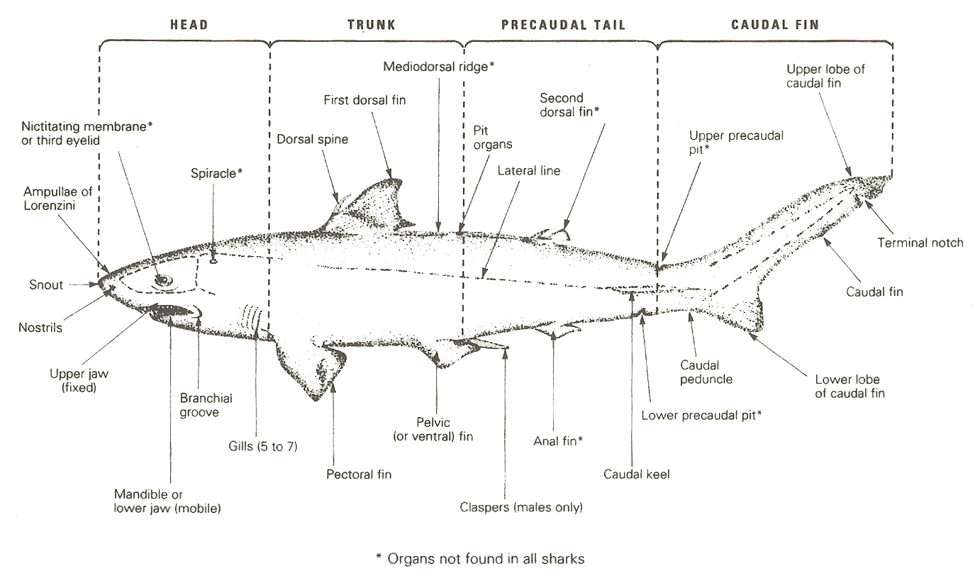

Now using your friendly chrome book, research and kindly describe the function of the listed structures below:

Lateral line

Ampullae of Lorenzini

Spiracle

Nictitating membrane

