LAB STATION C: Fossil Shark Teeth!

Fun Working with 50 million year old fossil shark’s teeth!
(Complete this station in your lab book please!)

I. Title: Investigation of Fossil Shark Teeth

II. Purpose: To become familiar with the anatomy of various extinct shark species.
To make the connection between ancient shark species and extant shark species.

III. Background Information

Shark continually shed their teeth during their lifetime. Because a shark skeleton is composed of cartilage and the teeth are the hardest part of a shark skeleton they are often the only fossil evidence left behind.

The most ancient types of sharks date back to 450 million years ago, during the late Ordovician period. However, the most commonly found fossil shark’s teeth are from the Cenozoic – during the last 65 million years.

The shape of sharks’ teeth vary according to their diet; those species that feed on crustaceans have dense, flattened teeth designed for crushing their food. Those that feed on fish have needle-like teeth for gripping, and those that feed on larger prey such as mammals have pointed lower teeth for gripping and triangular upper teeth with serrated edges for cutting.

The fossil shark teeth used for this lab are from sharks that lived 45 – 70 million years ago; they were found in fossil deposits from Morocco.

IV. Materials
Fossil Shark Teeth
Shark tooth identification poster
Shark key
Globe

V. Procedure:
A. Select 2 different shark teeth from your lab table.

B. Make a realistic sketch of each tooth, and label them #1 - #2.

C. Below each tooth, measure and record the length, width and depth of the tooth (cm).

D. Referring to the diagram below, label the following parts of each tooth:

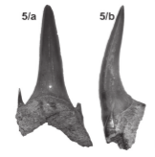 | 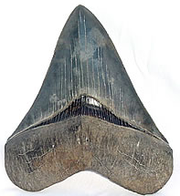

Root lobe
Bourlette
Serrations
Crown
Crown apex
Root
Basal Notch
Cusplet
Root Lobe
Labial face
Lingual face

E. Try to identify each tooth using the poster, and/or shark tooth key.
Label the species name above each tooth.

VI. Discussion
A. Can you guess where in the mouth each tooth was located? Give each a try.
B. Based upon the teeth, can you hypothesize what this shark ate as prey?
Explain your reasoning for each.
C. What are two adaptations shark’s teeth demonstrate?
D. Describe why shark teeth are most common fossil evidence of sharks?
E. Describe where Morocco is located on the globe.
F. List two things you learned about fossil sharks from this station.

